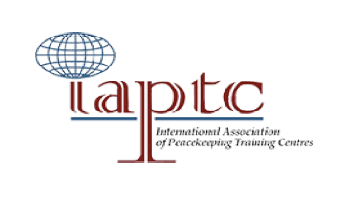 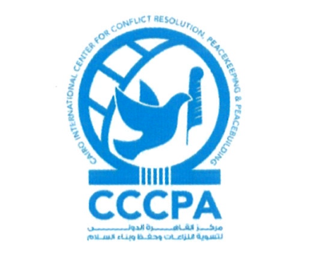

**Minutes**

**IAPTC Executive Committee Meeting (ECM)**

**6-8 May 2025 (In-person)**

**Vicenza, Italy**

| **Agenda ITEM** | **DISCUSSION** | **AGREEMENT/DECISION** |
| --- | --- | --- |
| 1- Opening of the Meeting | * The IAPTC President opened the meeting with welcoming remarks and invited the Executive Committee members to introduce themselves in a tour de table. * Following this, the presidency team provided a summary of lessons learned from the 28th Annual Conference held in Islamabad, Pakistan, from November 4th to November 8th, 2024, as well as suggestions for the 29th Annual Conference theme and sub-themes. |  |
| 2- The Secretariat Report | * The IAPTC Secretariat presented its report, followed by a presentation detailing the guidelines for the conference’s main theme and sub-themes. * The Secretariat presented an overview of the themes from previous Annual Conferences, along with a brief summary of the suggested themes and sub-themes for the 29th Annual Conference, as proposed by members and collected via the IAPTC webmail. * The pedagogical chair also presented some suggestions for themes and sub-themes. | The ExCom emphasized the importance of incorporating members’ suggestions when developing the agenda and actively engaging them in the conference program |
| 3- 29th IAPTC Annual Conference | * The host of the 29th Annual Conference, the Center of Excellence for Stability Police Units (CoESPU), delivered opening remarks and gave a presentation highlighting the Center’s activities. * The Host presented prospective venues for the 29th IAPTC Annual Conference as well as suggested themes and sub-themes for the conference. | 1. **IAPTC 29th Annual Conference will be physically held from 10-14 November 2025 at the Center for Stability Police Units (CoESPU) in Vicenza, Italy.** 2. Online registration will start once the website is launched and ready. 3. IAPTC members will be informed of updates regarding the annual conference in June 2025. |
| 4- Annual Conference Program | **Conference Theme :**   * The 29th IAPTC Annual Conference will be held under the theme *“Peace operations training in a dynamic world: fostering cooperation, inclusivity and efficiency.”* * **Topics to be discussed include :**  1. Peace Operations in a changing world: overview, challenges and opportunities; 2. Strategic communications and information integrity in peace operations contexts; 3. Harnessing emerging technologies for effective peace operations training; 4. Leveraging partnerships for peace operations (with an emphasis on African-led peace operations and other partnerships); 5. Effective pre-deployment preparation for operational readiness: best practices and lessons learned; 6. Mutual Engagement and Supportive Relationships between Host Countries and Peace Operations.   Spotlight Sessions:   1. Celebrating the Anniversaries of the Women, Peace and Security and Youth, Peace and Security Agendas. 2. Celebrating 30 Years of the IAPTC (1995-2025). | 1. IAPTC CDC Chair will develop the concept note for the annual conference, in coordination with the host and the ExCom members. 2. The ExCom members are tasked with compiling a list of speakers in order to finalize the agenda during the next meeting. 3. Updated agenda and list of speakers should be communicated to all ExCom members. 4. Gender balance, functional balance (civilian/police/military) and regional balance to be considered during speakers’ selection process. 5. The balance between the number of speakers and discussion time should be maintained, as highlighted during the past few Annual General Meetings. |
| 5- UN Police Day | The EC agreed to uphold UN Police Day, one day before the conference in accordance with previous editions (9 November 2025). | CoESPU, supported by the IAPTC Secretariat and the Police Chair, will initiate coordination with UNPOL for the organization of UN Police Day. |
| 6- Administrative and functioning matters | * Tanzania, as the host designate of the 30th IAPTC Annual Conference attended the meeting, officially joining the EC. * The term for the current Executive Committee Functional Chairs (Military / Police / Civilian / Pedagogical) ends with the organization of the 30th IAPTC Annual Conference. |  |
| 7- Follow-up | * All EC members expressed their willingness to actively contribute to the upcoming preparations for the IAPTC Annual Conference. | * The Secretariat is to inform the IAPTC community of the ECM decisions, and to update the website accordingly. |